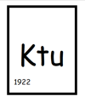

KAUNO TECHNOLOGIJOS UNIVERSITETAS

INFORMATIKOS FAKULTETAS

Programavimo kalbų teorija (P175B124)

Antro laboratorinio darbo ataskaita

Atliko:

Martynas Kuliešius IFF-1/9

Priėmė:

lekt. Guogis Evaldas

lekt. Fyleris Tautvydas

KAUNAS 2023

TURINYS

1. Scala (L2) 3

1.1. Darbo užduotis 3

1.2. Rezultatų pavyzdys 3

1.3. Programos tekstas 5

# Scala (L2)

## Darbo užduotis

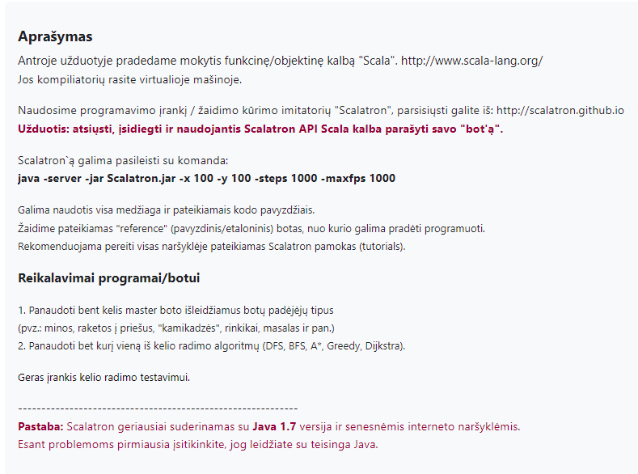

## Rezultatų pavyzdys

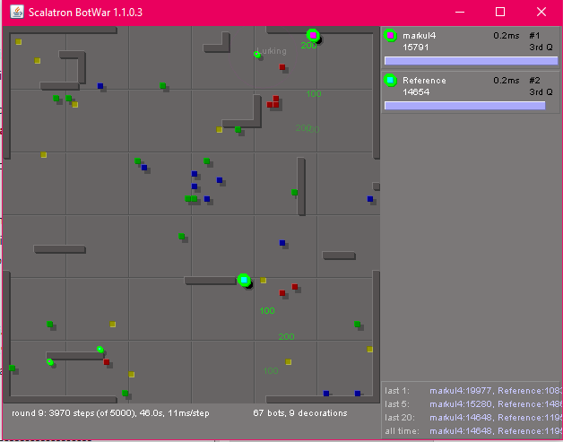

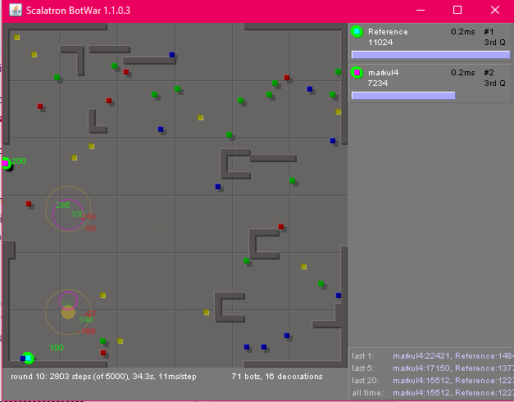

## Programos tekstas

// Martynas Kuliešius IFF-1/9

object ControlFunction

{

def forMaster(bot: Bot) {

val (directionValue, nearestEnemyMaster, nearestEnemySlave) = analyzeViewAsMaster(bot.view)

val dontFireAggressiveMissileUntil = bot.inputAsIntOrElse("dontFireAggressiveMissileUntil", -1)

val dontFireDefensiveMissileUntil = bot.inputAsIntOrElse("dontFireDefensiveMissileUntil", -1)

val lastDirection = bot.inputAsIntOrElse("lastDirection", 0)

// determine movement direction

directionValue(lastDirection) += 10 // try to break ties by favoring the last direction

val bestDirection45 = directionValue.zipWithIndex.maxBy(_._1)._2

val direction = XY.fromDirection45(bestDirection45)

val nextDirection = PathForMaster(bot.view, direction)

bot.move(nextDirection)

bot.set("lastDirection" -> bestDirection45)

val int = bot.view.offsetToNearest('m').getOrElse(XY(1000,1000))

val bint = bot.view.offsetToNearest('s').getOrElse(XY(1000,1000))

if( bot.energy > 0 && (bot.time % 30) == 0)

{

nearestEnemyMaster match {

case None =>

case Some(relPos) =>

val unitDelta = relPos.signum

val remainder = relPos - unitDelta

bot.spawn(unitDelta, "mood" -> "SnorgTempter", "target" -> remainder)

bot.say("I did it :D")

}

}

if ((closestEmaster.stepCount < 4 || closestEnemy.stepCount < 1) && bot.energy > 100 )

{

bot.spawn(XY(1,1), "mood" -> "Mine")

bot.say("Bomb!")

}

if (closestEnemy.stepCount < 6 && bot.energy > 75 )

{

bot.spawn(XY(1,1), "mood" -> "Bomb")

bot.say("Mine!")

}

if(dontFireAggressiveMissileUntil < bot.time && bot.energy > 100) { // fire attack missile?

nearestEnemyMaster match {

case None => // no-on nearby

case Some(relPos) => // a master is nearby

val unitDelta = relPos.signum

val remainder = relPos - unitDelta // we place slave nearer target, so subtract that from overall delta

bot.spawn(unitDelta, "mood" -> "Aggressive", "target" -> remainder)

bot.set("dontFireAggressiveMissileUntil" -> (bot.time + relPos.stepCount + 1))

}

}

else

if(dontFireDefensiveMissileUntil < bot.time && bot.energy > 100) { // fire defensive missile?

nearestEnemySlave match {

case None => // no-on nearby

case Some(relPos) => // an enemy slave is nearby

if(relPos.stepCount < 8) {

// this one's getting too close!

val unitDelta = relPos.signum

val remainder = relPos - unitDelta // we place slave nearer target, so subtract that from overall delta

bot.spawn(unitDelta, "mood" -> "Defensive", "target" -> remainder)

bot.set("dontFireDefensiveMissileUntil" -> (bot.time + relPos.stepCount + 1))

}

}

}

}

def forSlave(bot: MiniBot) {

bot.inputOrElse("mood", "Lurking") match {

case "Aggressive" => reactAsAggressiveMissile(bot)

case "Defensive" => reactAsDefensiveMissile(bot)

case "Mine" => reactAsMine (bot)

case "SnorgTempter" => reactAsSnorgTempter (bot)

case s: String => bot.log("unknown mood: " + s)

}

}

def reactAsMine (bot: MiniBot){

bot.view.offsetToNearest('m') match{

case Some(delta: XY) => if(delta.length <= 4){

bot.explode(6) }

case None =>

bot.set("mood" -> "Lurking", "target" -> "")

bot.say("Landmine")

}

}

def reactAsBomb(bot: MiniBot){

bot.explode(4)

}

def reactAsSnorgTempter(bot: MiniBot) {

bot.view.offsetToNearest('m') match {

case Some(delta: XY) =>

// another master is visible at the given relative position (i.e. position delta)

// if not too close, move closer

if(delta.length > 2) {

bot.move(delta.signum)

bot.set("rx" -> delta.x, "ry" -> delta.y)

}

case None =>

// no target visible -- follow our targeting strategy

val target = bot.inputAsXYOrElse("target", XY.Zero)

// did we arrive at the target?

if(target.isNonZero) {

// no -- keep going

val unitDelta = target.signum // e.g. CellPos(-8,6) => CellPos(-1,1)

bot.move(unitDelta)

// compute the remaining delta and encode it into a new 'target' property

val remainder = target - unitDelta // e.g. = CellPos(-7,5)

bot.set("target" -> remainder)

}

// else tempter is idle

}

}

def reactAsAggressiveMissile(bot: MiniBot) {

bot.view.offsetToNearest('m') match {

case Some(delta: XY) =>

// another master is visible at the given relative position (i.e. position delta)

// close enough to blow it up?

if(delta.length <= 2) {

// yes -- blow it up!

bot.explode(4)

} else {

// no -- move closer!

bot.move(delta.signum)

bot.set("rx" -> delta.x, "ry" -> delta.y)

}

case None =>

// no target visible -- follow our targeting strategy

val target = bot.inputAsXYOrElse("target", XY.Zero)

// did we arrive at the target?

if(target.isNonZero) {

// no -- keep going

val unitDelta = target.signum // e.g. CellPos(-8,6) => CellPos(-1,1)

bot.move(unitDelta)

// compute the remaining delta and encode it into a new 'target' property

val remainder = target - unitDelta // e.g. = CellPos(-7,5)

bot.set("target" -> remainder)

} else {

// yes -- but we did not detonate yet, and are not pursuing anything?!? => switch purpose

bot.set("mood" -> "Lurking", "target" -> "")

bot.say("Lurking")

}

}

}

def reactAsDefensiveMissile(bot: MiniBot) {

bot.view.offsetToNearest('s') match {

case Some(delta: XY) =>

// another slave is visible at the given relative position (i.e. position delta)

// move closer!

bot.move(delta.signum)

bot.set("rx" -> delta.x, "ry" -> delta.y)

case None =>

// no target visible -- follow our targeting strategy

val target = bot.inputAsXYOrElse("target", XY.Zero)

// did we arrive at the target?

if(target.isNonZero) {

// no -- keep going

val unitDelta = target.signum // e.g. CellPos(-8,6) => CellPos(-1,1)

bot.move(unitDelta)

// compute the remaining delta and encode it into a new 'target' property

val remainder = target - unitDelta // e.g. = CellPos(-7,5)

bot.set("target" -> remainder)

} else {

// yes -- but we did not annihilate yet, and are not pursuing anything?!? => switch purpose

bot.set("mood" -> "Lurking", "target" -> "")

bot.say("Lurking")

}

}

}

/** Analyze the view, building a map of attractiveness for the 45-degree directions and

* recording other relevant data, such as the nearest elements of various kinds.

*/

def analyzeViewAsMaster(view: View) = {

val directionValue = Array.ofDim[Double](8)

var nearestEnemyMaster: Option[XY] = None

var nearestEnemySlave: Option[XY] = None

val cells = view.cells

val cellCount = cells.length

for(i <- 0 until cellCount) {

val cellRelPos = view.relPosFromIndex(i)

if(cellRelPos.isNonZero) {

val stepDistance = cellRelPos.stepCount

val value: Double = cells(i) match {

case 'm' => // another master: not dangerous, but an obstacle

nearestEnemyMaster = Some(cellRelPos)

if(stepDistance < 2) -1000 else 0

case 's' => // another slave: potentially dangerous?

nearestEnemySlave = Some(cellRelPos)

-100 / stepDistance

case 'S' => // out own slave

0.0

case 'B' => // good beast: valuable, but runs away

if(stepDistance == 1) 600

else if(stepDistance == 2) 300

else (150 - stepDistance * 15).max(10)

case 'P' => // good plant: less valuable, but does not run

if(stepDistance == 1) 500

else if(stepDistance == 2) 300

else (150 - stepDistance * 10).max(10)

case 'b' => // bad beast: dangerous, but only if very close

if(stepDistance < 4) -400 / stepDistance else -50 / stepDistance

case 'p' => // bad plant: bad, but only if I step on it

if(stepDistance < 2) -1000 else 0

case 'W' => // wall: harmless, just don't walk into it

if(stepDistance < 2) -1000 else 0

case _ => 0.0

}

val direction45 = cellRelPos.toDirection45

directionValue(direction45) += value

}

}

(directionValue, nearestEnemyMaster, nearestEnemySlave)

}

def Obsticless(where: XY, view:View) = {

view.cellAtRelPos(where) match{

case 'M' => true

case 'm' => false

case 's' => false

case 'S' => false

case 'B' => true

case 'P' => true

case 'b' => false

case 'p' => false

case 'W' => false

case '_' => true

case '?' => true

case _ => false

}

}

def PathForMaster(view: View, random: XY) =

{

val blue = GetPath(view, 'B', 125)

if (blue == XY(0,0))

{

val plant = GetPath(view, 'P', 125)

if (plant == XY(0,0))

{

if (plant == XY(0,0))

{

random

}

else

{

plant

}

}

else

{

plant

}

}

else

{

blue

}

}

case class Location(xy: XY, distance:Int, direction:Int){

}

def GetPath(view: View, find: Char, maxSearch: Int): XY = {

var counter = 0;

var locationQueue = new scala.collection.mutable.Queue[Location]()

val size = view.cells.size;

val length = view.cells.length;

def visited = new Array[Boolean](length)

def starting = XY(0,0)

var bestFind = new Location(new XY(0,0), 999, -1)

locationQueue.enqueue(new Location(starting, 0, -1))

while(!locationQueue.isEmpty && counter < maxSearch)

{

counter = counter + 1;

var current = locationQueue.dequeue()

visited(view.indexFromRelPos(current.xy)) = true

for (direction <- Seq(1,3,5,7,0,2,4,6))

{

val goingTo = current.xy + XY.fromDirection45(direction);

if(Obsticless(goingTo, view))

{

val newLocationDirection = if(current.direction != -1) current.direction else direction

val newLocation = new Location(goingTo, current.distance + 1, newLocationDirection)

if(newLocation.distance < bestFind.distance && view.cellAtRelPos(goingTo) == find)

{

bestFind = newLocation

}

locationQueue.enqueue(new Location(goingTo, current.distance + 1, newLocationDirection))

}

}

}

if (bestFind.direction != -1) XY.fromDirection45(bestFind.direction) else new XY(0,0)

}

}

// -------------------------------------------------------------------------------------------------

// Framework

// -------------------------------------------------------------------------------------------------

class ControlFunctionFactory {

def create = (input: String) => {

val (opcode, params) = CommandParser(input)

opcode match {

case "React" =>

val bot = new BotImpl(params)

if( bot.generation == 0 ) {

ControlFunction.forMaster(bot)

} else {

ControlFunction.forSlave(bot)

}

bot.toString

case _ => "" // OK

}

}

}

// -------------------------------------------------------------------------------------------------

trait Bot {

// inputs

def inputOrElse(key: String, fallback: String): String

def inputAsIntOrElse(key: String, fallback: Int): Int

def inputAsXYOrElse(keyPrefix: String, fallback: XY): XY

def view: View

def energy: Int

def time: Int

def generation: Int

// outputs

def move(delta: XY) : Bot

def say(text: String) : Bot

def status(text: String) : Bot

def spawn(offset: XY, params: (String,Any)*) : Bot

def set(params: (String,Any)*) : Bot

def log(text: String) : Bot

}

trait MiniBot extends Bot {

// inputs

def offsetToMaster: XY

// outputs

def explode(blastRadius: Int) : Bot

}

case class BotImpl(inputParams: Map[String, String]) extends MiniBot {

// input

def inputOrElse(key: String, fallback: String) = inputParams.getOrElse(key, fallback)

def inputAsIntOrElse(key: String, fallback: Int) = inputParams.get(key).map(_.toInt).getOrElse(fallback)

def inputAsXYOrElse(key: String, fallback: XY) = inputParams.get(key).map(s => XY(s)).getOrElse(fallback)

val view = View(inputParams("view"))

val energy = inputParams("energy").toInt

val time = inputParams("time").toInt

val generation = inputParams("generation").toInt

def offsetToMaster = inputAsXYOrElse("master", XY.Zero)

// output

private var stateParams = Map.empty[String,Any] // holds "Set()" commands

private var commands = "" // holds all other commands

private var debugOutput = "" // holds all "Log()" output

/** Appends a new command to the command string; returns 'this' for fluent API. */

private def append(s: String) : Bot = { commands += (if(commands.isEmpty) s else "|" + s); this }

/** Renders commands and stateParams into a control function return string. */

override def toString = {

var result = commands

if(!stateParams.isEmpty) {

if(!result.isEmpty) result += "|"

result += stateParams.map(e => e._1 + "=" + e._2).mkString("Set(",",",")")

}

if(!debugOutput.isEmpty) {

if(!result.isEmpty) result += "|"

result += "Log(text=" + debugOutput + ")"

}

result

}

def log(text: String) = { debugOutput += text + "\n"; this }

def move(direction: XY) = append("Move(direction=" + direction + ")")

def say(text: String) = append("Say(text=" + text + ")")

def status(text: String) = append("Status(text=" + text + ")")

def explode(blastRadius: Int) = append("Explode(size=" + blastRadius + ")")

def spawn(offset: XY, params: (String,Any)*) =

append("Spawn(direction=" + offset +

(if(params.isEmpty) "" else "," + params.map(e => e._1 + "=" + e._2).mkString(",")) +

")")

def set(params: (String,Any)*) = { stateParams ++= params; this }

def set(keyPrefix: String, xy: XY) = { stateParams ++= List(keyPrefix+"x" -> xy.x, keyPrefix+"y" -> xy.y); this }

}

// -------------------------------------------------------------------------------------------------

/** Utility methods for parsing strings containing a single command of the format

* "Command(key=value,key=value,...)"

*/

object CommandParser {

/** "Command(..)" => ("Command", Map( ("key" -> "value"), ("key" -> "value"), ..}) */

def apply(command: String): (String, Map[String, String]) = {

/** "key=value" => ("key","value") */

def splitParameterIntoKeyValue(param: String): (String, String) = {

val segments = param.split('=')

(segments(0), if(segments.length>=2) segments(1) else "")

}

val segments = command.split('(')

if( segments.length != 2 )

throw new IllegalStateException("invalid command: " + command)

val opcode = segments(0)

val params = segments(1).dropRight(1).split(',')

val keyValuePairs = params.map(splitParameterIntoKeyValue).toMap

(opcode, keyValuePairs)

}

}

// -------------------------------------------------------------------------------------------------

/** Utility class for managing 2D cell coordinates.

* The coordinate (0,0) corresponds to the top-left corner of the arena on screen.

* The direction (1,-1) points right and up.

*/

case class XY(x: Int, y: Int) {

override def toString = x + ":" + y

def isNonZero = x != 0 || y != 0

def isZero = x == 0 && y == 0

def isNonNegative = x >= 0 && y >= 0

def updateX(newX: Int) = XY(newX, y)

def updateY(newY: Int) = XY(x, newY)

def addToX(dx: Int) = XY(x + dx, y)

def addToY(dy: Int) = XY(x, y + dy)

def +(pos: XY) = XY(x + pos.x, y + pos.y)

def -(pos: XY) = XY(x - pos.x, y - pos.y)

def *(factor: Double) = XY((x * factor).intValue, (y * factor).intValue)

def distanceTo(pos: XY): Double = (this - pos).length // Phythagorean

def length: Double = math.sqrt(x * x + y * y) // Phythagorean

def stepsTo(pos: XY): Int = (this - pos).stepCount // steps to reach pos: max delta X or Y

def stepCount: Int = x.abs.max(y.abs) // steps from (0,0) to get here: max X or Y

def signum = XY(x.signum, y.signum)

def negate = XY(-x, -y)

def negateX = XY(-x, y)

def negateY = XY(x, -y)

/** Returns the direction index with 'Right' being index 0, then clockwise in 45 degree steps. */

def toDirection45: Int = {

val unit = signum

unit.x match {

case -1 =>

unit.y match {

case -1 =>

if(x < y * 3) Direction45.Left

else if(y < x * 3) Direction45.Up

else Direction45.UpLeft

case 0 =>

Direction45.Left

case 1 =>

if(-x > y * 3) Direction45.Left

else if(y > -x * 3) Direction45.Down

else Direction45.LeftDown

}

case 0 =>

unit.y match {

case 1 => Direction45.Down

case 0 => throw new IllegalArgumentException("cannot compute direction index for (0,0)")

case -1 => Direction45.Up

}

case 1 =>

unit.y match {

case -1 =>

if(x > -y * 3) Direction45.Right

else if(-y > x * 3) Direction45.Up

else Direction45.RightUp

case 0 =>

Direction45.Right

case 1 =>

if(x > y * 3) Direction45.Right

else if(y > x * 3) Direction45.Down

else Direction45.DownRight

}

}

}

def rotateCounterClockwise45 = XY.fromDirection45((signum.toDirection45 + 1) % 8)

def rotateCounterClockwise90 = XY.fromDirection45((signum.toDirection45 + 2) % 8)

def rotateClockwise45 = XY.fromDirection45((signum.toDirection45 + 7) % 8)

def rotateClockwise90 = XY.fromDirection45((signum.toDirection45 + 6) % 8)

def wrap(boardSize: XY) = {

val fixedX = if(x < 0) boardSize.x + x else if(x >= boardSize.x) x - boardSize.x else x

val fixedY = if(y < 0) boardSize.y + y else if(y >= boardSize.y) y - boardSize.y else y

if(fixedX != x || fixedY != y) XY(fixedX, fixedY) else this

}

}

object XY {

/** Parse an XY value from XY.toString format, e.g. "2:3". */

def apply(s: String) : XY = { val a = s.split(':'); XY(a(0).toInt,a(1).toInt) }

val Zero = XY(0, 0)

val One = XY(1, 1)

val Right = XY( 1, 0)

val RightUp = XY( 1, -1)

val Up = XY( 0, -1)

val UpLeft = XY(-1, -1)

val Left = XY(-1, 0)

val LeftDown = XY(-1, 1)

val Down = XY( 0, 1)

val DownRight = XY( 1, 1)

def fromDirection45(index: Int): XY = index match {

case Direction45.Right => Right

case Direction45.RightUp => RightUp

case Direction45.Up => Up

case Direction45.UpLeft => UpLeft

case Direction45.Left => Left

case Direction45.LeftDown => LeftDown

case Direction45.Down => Down

case Direction45.DownRight => DownRight

}

def fromDirection90(index: Int): XY = index match {

case Direction90.Right => Right

case Direction90.Up => Up

case Direction90.Left => Left

case Direction90.Down => Down

}

def apply(array: Array[Int]): XY = XY(array(0), array(1))

}

object Direction45 {

val Right = 0

val RightUp = 1

val Up = 2

val UpLeft = 3

val Left = 4

val LeftDown = 5

val Down = 6

val DownRight = 7

}

object Direction90 {

val Right = 0

val Up = 1

val Left = 2

val Down = 3

}

// -------------------------------------------------------------------------------------------------

case class View(cells: String) {

val size = math.sqrt(cells.length).toInt

val center = XY(size / 2, size / 2)

def apply(relPos: XY) = cellAtRelPos(relPos)

def indexFromAbsPos(absPos: XY) = absPos.x + absPos.y * size

def absPosFromIndex(index: Int) = XY(index % size, index / size)

def absPosFromRelPos(relPos: XY) = relPos + center

def cellAtAbsPos(absPos: XY) = cells.charAt(indexFromAbsPos(absPos))

def indexFromRelPos(relPos: XY) = indexFromAbsPos(absPosFromRelPos(relPos))

def relPosFromAbsPos(absPos: XY) = absPos - center

def relPosFromIndex(index: Int) = relPosFromAbsPos(absPosFromIndex(index))

def cellAtRelPos(relPos: XY) = cells.charAt(indexFromRelPos(relPos))

def offsetToNearest(c: Char) = {

val matchingXY = cells.view.zipWithIndex.filter(_._1 == c)

if( matchingXY.isEmpty )

None

else {

val nearest = matchingXY.map(p => relPosFromIndex(p._2)).minBy(_.length)

Some(nearest)

}

}

}